Гуманитарный проект государственного учреждения образования «Слонимский районный центр дополнительного образования детей и молодежи» ищет спонсоров

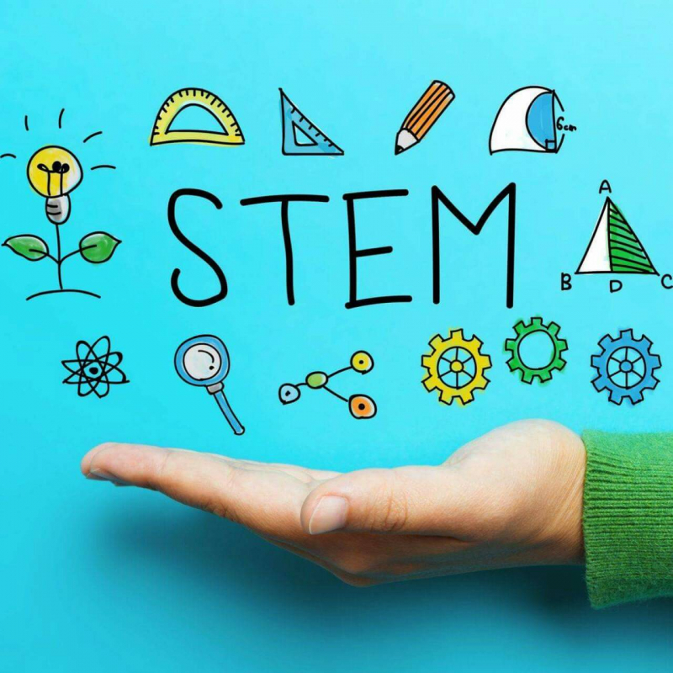
Цель проекта: модернизация образовательной среды учреждения средствами STEM-обучения в условиях дополнительного образования.

- Наименование проекта: «Создание stem-центра»
- Срок реализации проекта: 12 месяцев
- Организация - заявитель, предлагающая проект: государственное учреждение образования «Слонимский районный центр дополнительного образования детей и молодежи»
4. Цель проекта: модернизация образовательной среды учреждения средствами STEM-обучения в условиях дополнительного образования.
5. Задачи, планируемые к выполнению в рамках реализации проекта:

- Создать STEM-центр – технически оснащенную площадку в ГУО «Слонимский районный центр дополнительного образования детей и молодежи», где могут бесплатно заниматься школьники, заинтересованные в точных, естественных, инженерных науках, технологиях и искусстве.
- Обеспечить проведение занятий на принципах межпредметности, проектного и практикоориентированного характера обучения, активной позиции ученика.
- Внедрить в практическую деятельность эффективный механизм организации работы по ранней профориентации учащихся в сфере высоких технологий, инженерных профессий.
- Разработать образовательную программу для педагогов по пониманию и реализации STEAM-принципов в обучении, повысить квалификацию педагогов по направлению робототехника.
- Открыть образовательный клуб для детей, находящихся в социально опасном положении, признанных нуждающимися в государственной защите, и их родителей (совместные занятия).
- Открыть Консультационный пункт дистанционного обучения для ребят, проживающих в сельской местности.
- Открыть объединения по интересам:
для дошкольников:
Lego - конструирование
для учащихся младших классов:
- Занимательный компьютер,
- «Game LAB»
- Мультстудия
- Scratch –программирование
- Исследователь
для учащихся среднего и старшего возраста:
- «Перворобот»
- «Робототехника (Lego)»
- «Робототехника (ARDUINO)»
- «Видеомонтаж»
- «3D моделирование»
6. Целевая группа: учащиеся общеобразовательных учреждений, дети, находящиеся в социально опасном положении, признанные нуждающимися в государственной защите, и их родители.
7. Краткое описание мероприятий в рамках проекта:
- Создать STEM-центр на базе ГУО «Слонимский районный центр дополнительного образования детей и молодежи». Организовать рабочую группу по внедрению проекта, развитию и популяризации STEM – образования.
2. Организовать проведение открытых мероприятий на базе центра, сетевое взаимодействие с ассоциацией «Образование для будущего», Национальным детским технопарком, РУП «Технолаб», учреждениями общего среднего образования, средними специальными и высшими учебными заведениями, проведение открытых занятий и мастер-классов, публикации в сети Интернет и методических изданиях.
8. Общий объем финансирования (в долларах | США): 20 000
Источник финансирования | Объем финансирования (в долларах США)
Средства донора | 15000
Софинансирование | 5000
9. Место реализации проекта (область/район, город): Гродненская область, Слонимский район, город Слоним
10. Контактное лицо:
С.А.Царук, директор ГУО «Слонимский районный центр дополнительного образования детей и молодежи», телефон 801562 65677,
e-mail: email@ctur.by

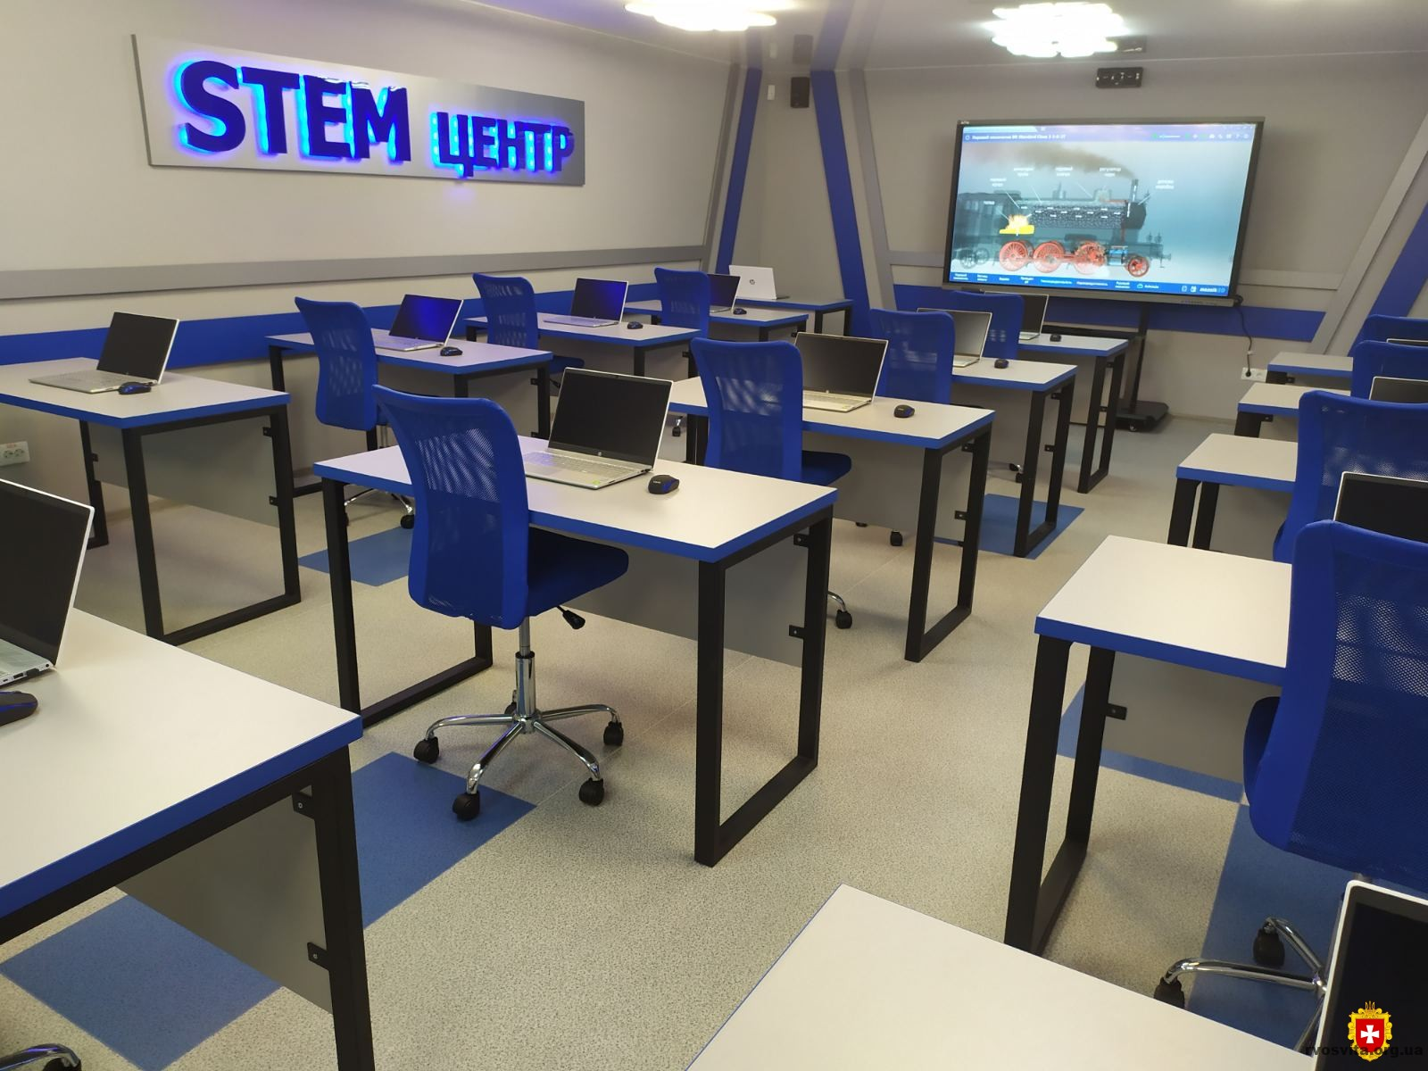

Будем рады сотрудничеству!

Humanitarian project of the state institution of education «Slonim district centre of additional education for children and youth». is looking for sponsors

Aim of the project: modernization of the educational environment of the institution by means of STEM-training in the conditions of additional education
1. Project name: «Creating a stem center»
2. Project implementation period: 12 months
3. Organization, which offers a project: state institution of education «Slonim district centre of additional education for children and youth»
4. Aim of the project: modernization of the educational environment of the institution by means of STEM-training in the conditions of additional education
5. Tasks to be realized while the project implementation:
- Create a STEM center - a technically equipped platform in «Slonim center for additional education of children and youth», where students interested in exact, natural, engineering, technology and art can study for free.
- Ensure that classes are conducted on the principles of intersubject, project-based and practice-oriented nature of training, and the active position of the student.
- Implement in practice an effective mechanism for organizing work on early career guidance of students in the field of high technologies and engineering professions.
- Develop an educational program for teachers to understand and implement the STEAM principles in training, improve the skills of teachers in the field of robotics.
- Open an educational club for children who are recognized as needing state protection and their parents who are in a socially dangerous situation (joint classes).
- Open a distance learning Consultation point for children living in rural areas.
- Open associations by interests: for preschoolers: Lego construction for elementary school students: Entertaining computer, "Game LAB", Cartoon Studio, Scratch programming. Researcher for middle-aged and older students: "pervorobot", "Robotics (Lego)", "Robotics (ARDUINO)", "Video editing", "3D modeling.
6. Task group: students of General education institutions, children recognized as needing state protection, and their parents who are in a socially dangerous situation.
7. Brief description of the events within the framework of the project:
Create a STEM center-a technically equipped platform in the Slonim district center for additional education of children and youth, where students interested in exact, natural, engineering, technology and art can study for free. Creating a working group to implement the project, develop and promote STEM education. Conducting open events on the basis of the center. Organization of network interaction with the Association "Education for the future", the National children's Technopark, "Technolab", institutions of General secondary education, secondary special and higher educational institutions. Conducting open classes and master classes. Publications on the Internet and methodological publications.
8. Total funding (dollars USA): 20 000
Source of funding | Amount of financing  (dollars USA)
Contributor | 15 000
Co-financing | 5000
9. Place of the project implementation (region/district, town): Grodno region, Slonim district, Slonim city
10.Contact person: Mrs Tsaruk Svetlana Anatolevna
tel.: 801562 65677, е-mail: email@ctur.by

We look forward to collaborating!

